Online Retail Management

* 1. Research and list at least five benefits of cloud computing over traditionale on-premises infrastructure

 In traditional systems used by offline retailers, they struggle to integrate with modern technologies and can be expensive to maintain. Cloud computing empowers retailers with a competitive advantage over their e-commerce competitors by offering enhanced flexibility. The retail landscape is expanding far beyond the realms of traditional enterprise resource planning, Customer relation management and supply chain management (SCM).

In today's rapidly evolving retail landscape, embracing cloud retail solutions has become more effective.. Among the technologies, cloud computing stands out as a game-changer – streamlining workflows, combining IT expenses and enhancing the overall customer experience. By embracing cloud computing in retail, businesses can unlock benefits that contribute to their success in the digital era.

Advantages of cloud computing in retail

#### Cost-effective existence

#### With cloud technology, retailers only pay for the resources they actually use. This brings considerable savings to their operational expenditure budget as they no longer need to worry about investing in hardware, software and connectivity. Additionally, the burden of system updates is shifted to the managed services provider, relieving retailers of such responsibilities. This streamlined approach also reduces the need to hire dedicated IT personnel, further adding to the cost savings offered by cloud computing in the retail sector.

#### Scalability advantages

IT systems must be equipped to handle these ever-changing scenarios seamlessly. This is where the scalability advantage of cloud computing in retail becomes a game-changer.Target an American retail corporation, uses cloud computing to power its website and mobile app, ensuring that it can handle high traffic volumes during peak shopping seasons.

1. Elasticity

With a cloud-based model, retailers can easily adjust the level of resources to match their actual usage, swiftly scaling up or down as needed, all in a cost-effective manner. Cloud computing in retail empowers businesses to seamlessly handle peak demand periods, ensuring that they can meet customer expectations without any problems.

4.Better supply chain visibility

Cloud computing retail can result in fewer stock-outs and optimized inventory levels and can also enable retailers to capture real-time location data on inventory and compare their stock with that of other locations. Using cloud computing, retailers can assess each individual element of the supply chain, from order status to product marketing. Cloud technology can automatically record relevant data that retailers can then use to make changes to their business processes.

#### 5.Agile

#### Catalyst to create new products: Data analytics capabilities delivered by cloud computing in retail serve as a powerful tool for retailers to create innovative new products driven by customer feedback. Leveraging this technology, retailers can compile valuable information from various online sources, including competitor retailers and social media platforms, to gain insights into customer preferences and desires.

#### 1.2 Describe the CapEx and OpEx models of financing IT infrastructure, providing examples of when each model might be preferred.

A capital expenditure, or Capex, is money invested by a company to acquire or upgrade fixed, physical or non consumable assets. Capex is primarily a one-time investment in non consumable assets used to maintain existing levels of operation within a company and to foster its future growth.

Operating expenses are what it costs you to run your business. Financial experts and other business owners sometimes use the term OPEX to mean the same thing. Some common operating expenses in retail include inventory purchases, product shipping, marketing and advertising, and payroll.

3.1 Create a brief report differentiating between public, private, and hybrid clouds. Include a diagram that represents each cloud model.

* [**Public Cloud**](https://www.knowledgehut.com/blog/cloud-computing/public-cloud) is like any other public service, for example, YouTube. Anyone can create an account there. It supports multitenancy, like an apartment. Anyone can pay their share and use it for themselves.

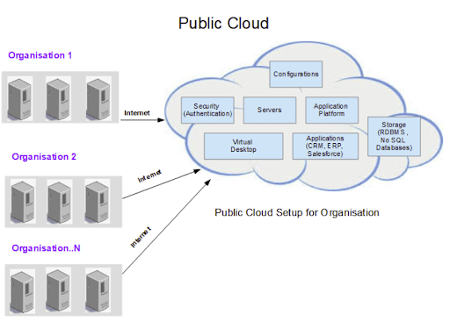

* Private Cloud is like an internal email server of companies, not everyone can use it directly. It is like a house. It can be accessed only within the organization. They require allocations of space, hardware, and environmental controls.

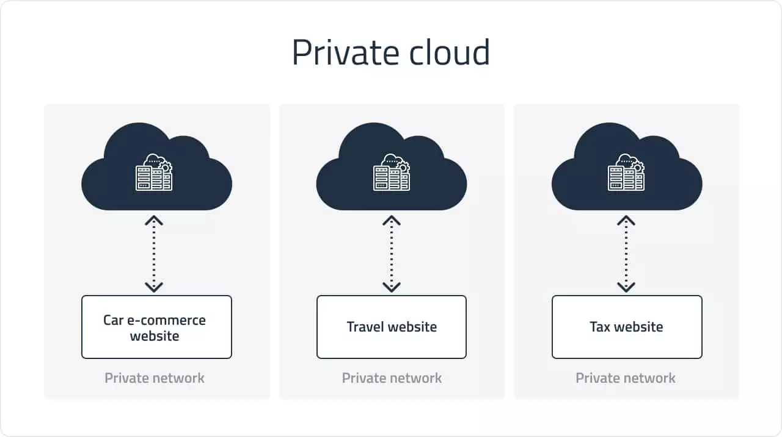

* A hybrid Cloud is a combination of public and private clouds. They possess the components of both public as well as a private cloud. The infrastructure is decided after considering a lot of factors. For example, a database might be configured in a private cloud, whereas the frontend component is in a public cloud. A hybrid cloud allows connecting both the cloud deployment models.

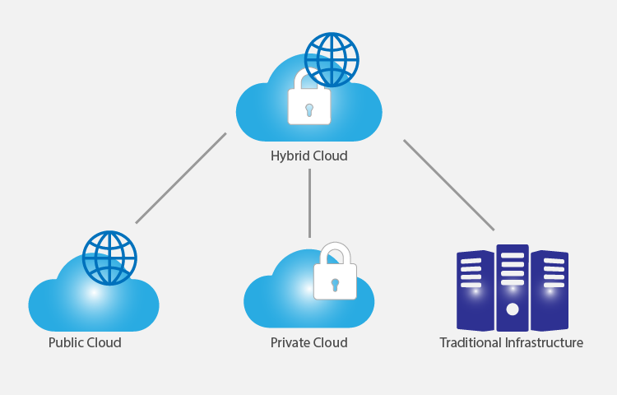

#### For each cloud model, list one real-world application or scenario where that model would be the most appropriate choice.

1.Public Cloud:

Real-World Application: A startup company developing a new mobile app chooses to host their app on a public cloud platform. The company has limited resources and wants to minimize upfront costs. They also anticipate a variable and potentially high volume of users, making the scalability of public cloud resources ideal for their needs.

2.Private Cloud:

Real-World Application: A financial services firm with strict regulatory requirements decides to build a private cloud to host its financial data and applications. The firm needs to ensure data privacy, security, and compliance with regulations such as GDPR and HIPAA. A private cloud allows the firm to have full control over its infrastructure and data, meeting its security and compliance needs.

3.Hybrid Cloud:

Real-World Application: A retail company uses a hybrid cloud model to manage its e-commerce platform. The company uses the public cloud for hosting its website and handling peak shopping seasons when traffic is high. It uses a private cloud for sensitive data such as customer financial information, ensuring security and compliance with industry regulations. The hybrid cloud model allows the company to scale resources up or down based on demand while maintaining control over sensitive data.